DATA HANDLING USING ‘Pandas’ and DATA VISUALIZATION USING ‘Seaborn’

Using the pandas function read_csv(), read the given ‘iris’ data set.

- Use appropriate functions in pandas to display
- Shape of the data set
- First 5 and last five rows of data set(head and tail)
- Size of dataset
- No:of samples available for each variety
- Description of the data set( use describe
code
import numpy as np
import matplotlib.pyplot as plt
import seaborn as sns
import pandas as pd
col=['sepal_length','sepal_width','petal_length','petal_width','variety']
iris=pd.read_csv("iris.csv",names=col)
print(col)
#shape 1
print(iris.shape)

#2
print(iris.head())

print(iris.tail())
#3
print("size",iris.size)
#4
print(iris["variety"].value_counts())
#5
print(iris.describe())

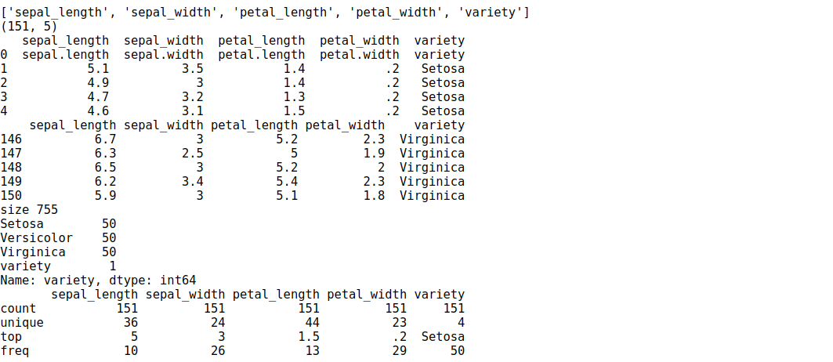

2. Use pairplot() function to display pairwise relationships between attributes. Try different kind of plots {‘scatter’, ‘kde’, ‘hist’, ‘reg’} and different kind of markers

code
ir = sns.load_dataset('iris')
g = pd.DataFrame(ir)

g1=sns.pairplot(g,kind="hist", hue="species",height=3)

g1=sns.pairplot(g,kind="kde" , hue="species", vars=["sepal_length","petal_length"])
g1=sns.pairplot(g,kind="scatter" ,hue="species",markers=["o","s","D"])
g1=sns.pairplot(g,kind="reg" ,hue="species")

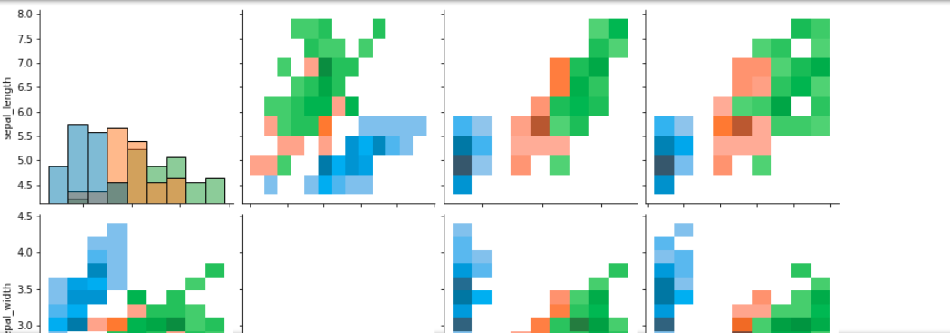

3.using the iris data set,get familiarize with functions:
1)displot()
2) histplot()
3) relplot()

code
sns.relplot(data=ir)
sns.displot(data=ir)
sns.histplot(data=ir,)
